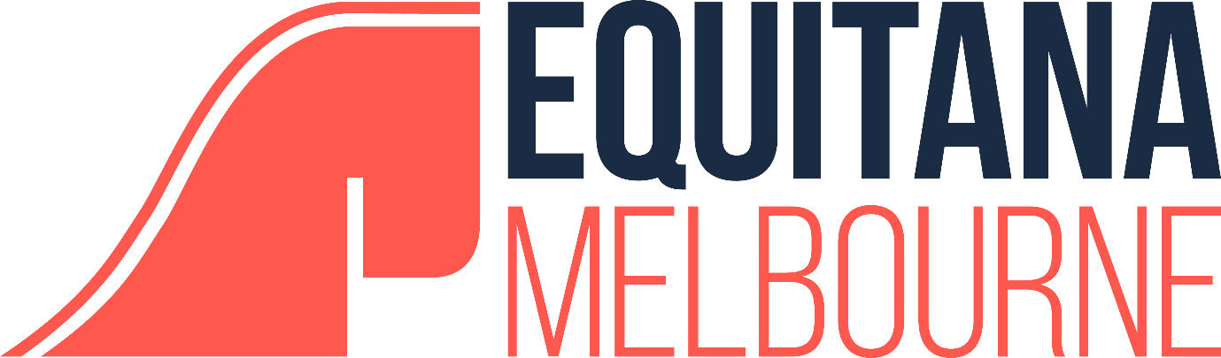

THE WAY OF THE HORSE
RESULTS

Place | Competitor
First | Skye Liikanen
Second | Hayley Hinton
Third | Steph Lancefield

